**Segmentation of London Boroughs based on Primary School Reputations and Venue Categories**

Melek Hatipoglu

July 27, 2020

# Introduction

## Background

London is the capital and largest city of England and United Kingdom. Beside that London is one of the financial capitals of the world. Therefore there are limitless of business opportunities this makes London very attractive for business professionals.

London is considered to be one of the world's most important global cities and has been called the world's most powerful,most desirable,most influential,most visited,most expensive,sustainable,most investment-friendly,and most-popular-for-work city (Figure1). It exerts a considerable impact upon the arts, commerce, education, entertainment, fashion, finance, healthcare, media, professional services, research and development, tourism and transportation.London ranks 26th out of 300 major cities for economic performance.It is one of the largest financial centres and has either the fifth- or the sixth-largest metropolitan area GDP.

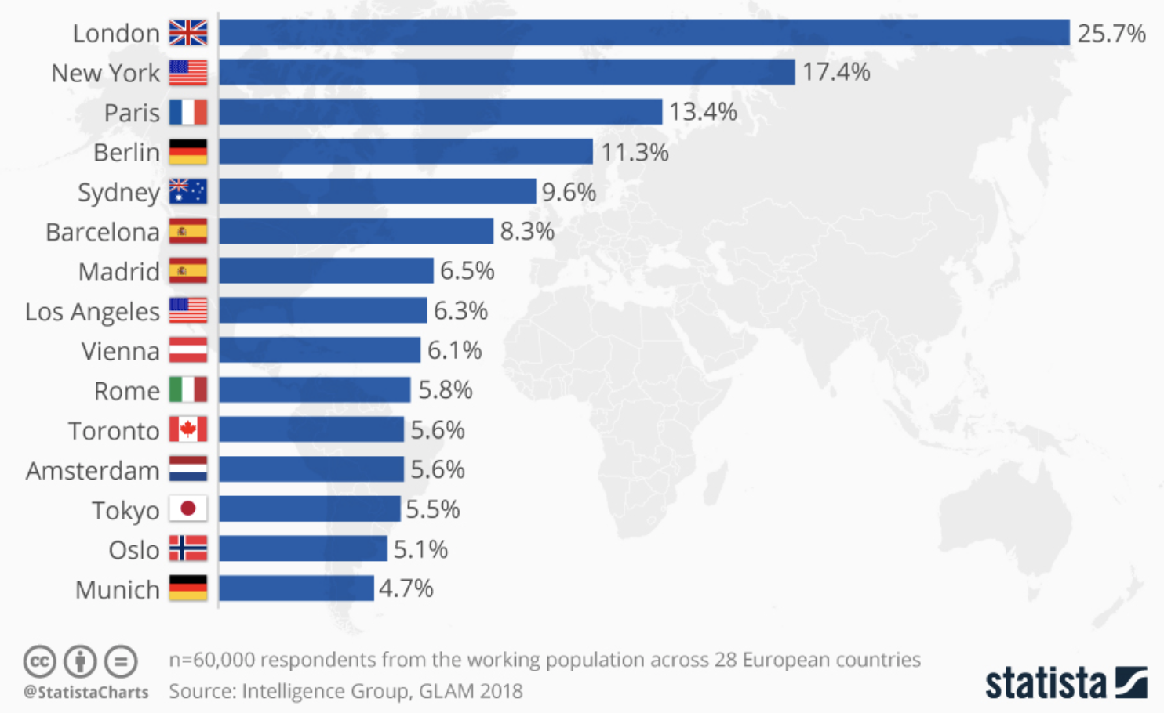

Figure 1: Most popular cities to work in among Europeans 2018 by Statista

Many expats moving to London with their families need guidance according to their personal needs and family interests. As London is very big city, for the new comers it can be challenging to take correct decision for settlement.

In this project a family with 2 kids is moving to London from US for business purposes. Their first priority on choosing a Neighbourhood is Primary School Education Rating and family friendly venues (Parks, Museums, Art galleries etc.).

## Purpose

The purpose of the Project is to implement a recommendation engine to families with small kids which prefer to live in near of schools that has high education quality and family friendly places. Therefore similar solutions based on the preferences of families can be implemented by companies who bring experts from other countries or third party agencies.

# Data Acquisition

## Data Sources

According to the needs of the problem, UK primary schools rating/reputation data is required. Along with this information, venues per each London boroughs and their categories with frequencies have been utilized.

The office for Standard in Education (OFSTED) is periodically releasing an inspection reports for the education qualities of the primary schools in UK. This data is published and can be taken from [www.compare-school-performance.service.gov.uk](http://www.compare-school-performance.service.gov.uk) as csv format.

The venues data of the boroughs in London has been scraped from Foursquare API.

## Data Filtering and Cleaning

Primary school data has been downloaded(Figure 2), and filtered for London. Irrelevant columns have been dropped.

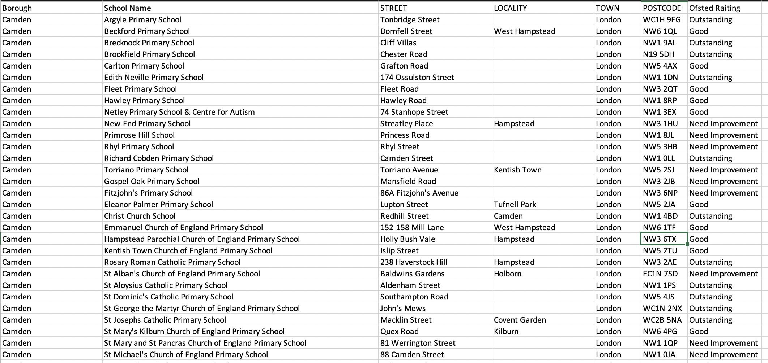

Figure 2: Example Screenshot of the School Data

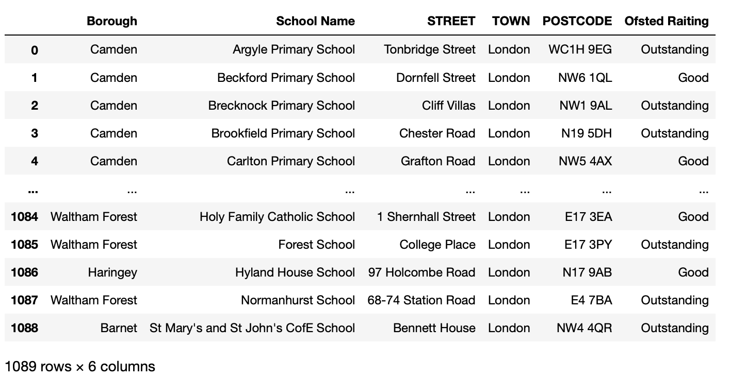

Figure 3: Example Screenshot of the School Data

The venues data of each boroughs, Foursquare API explore url was utilized. Before running the foursquare query, Longitude and Latitude information of the borough were fetched by GeoPy API of Python.

# Methodology

## APIs and Tools used

Github has been used for version control and having a common repo to store all relevant information.

The venues data of each boroughs, Foursquare API explore url was utilized. Before running the foursquare query, Longitude and Latitude information of the borough were fetched by GeoPy API of Python.

Folium API has been utilized to visualize the school locations on the London Map.

I also used time library to execute sleep method while scraping latitude and longitude data from geopy which allows only 1 data per second on free account.

## Exploratory Data Analysis

There are 27 Boroughs and 1073 Primary Schools ranked as „Outstanding“, „Good“ and „Need Improvement“ in London.

Ofsted School Ratings were converted from string to integer as „Outstanding=3“, „Good“=2 and „Need Improvement=1“ in ordert o utilize for Kmeans Clustering method.

The primary schools in London were grouped per boroughs and boroughs were listed with average rating of the schools in them and venue category frequencies.

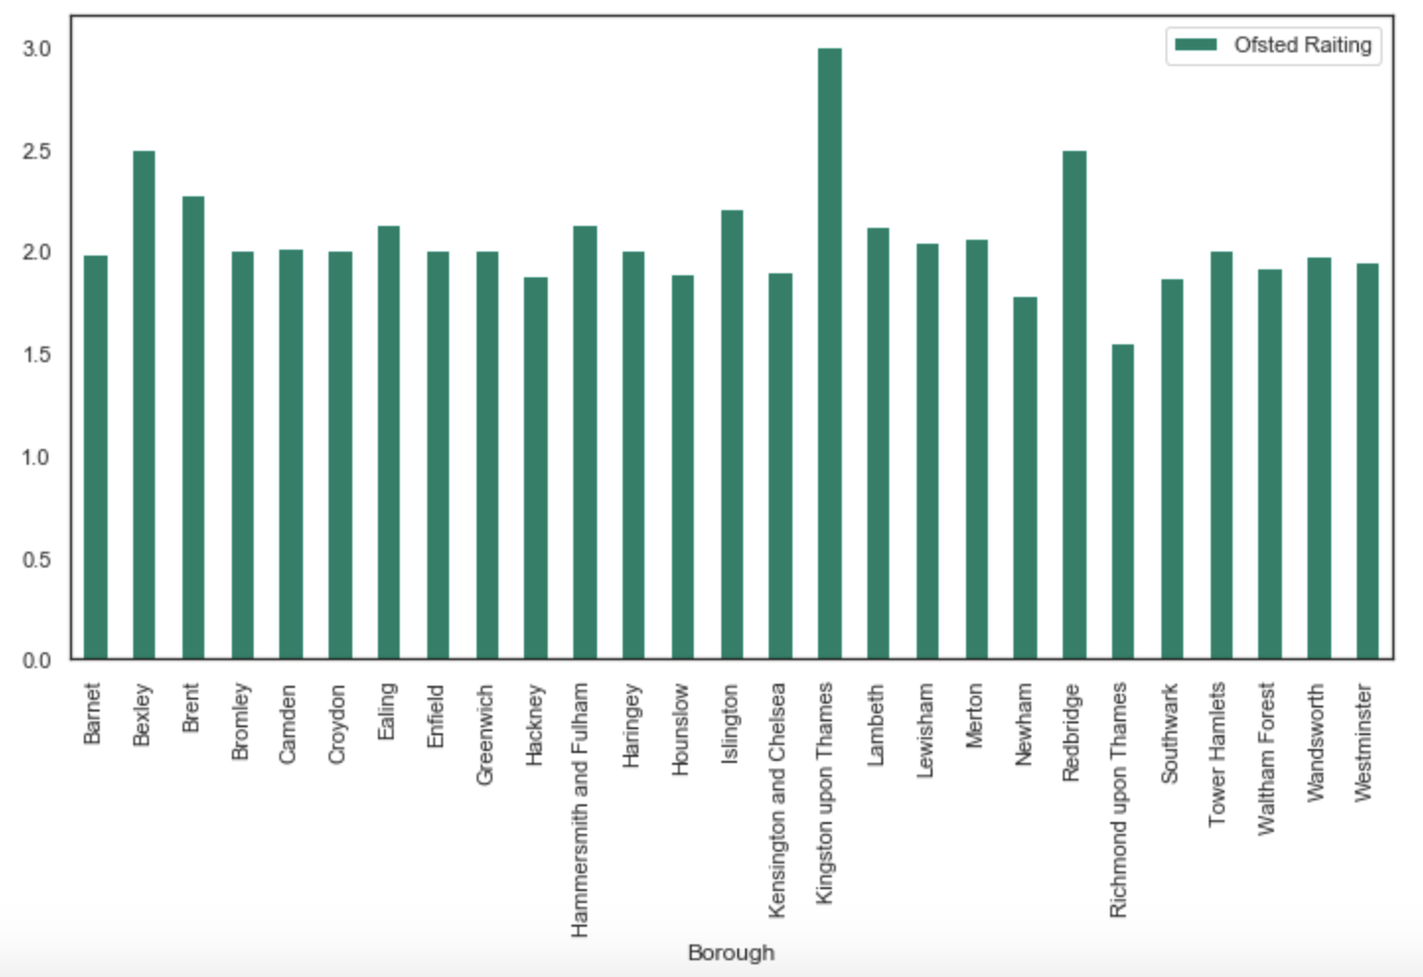

Figure 4: Average Primary School Ratings of the Boroughs

Center points to the primary schools of each borough have been visualized with folium map.

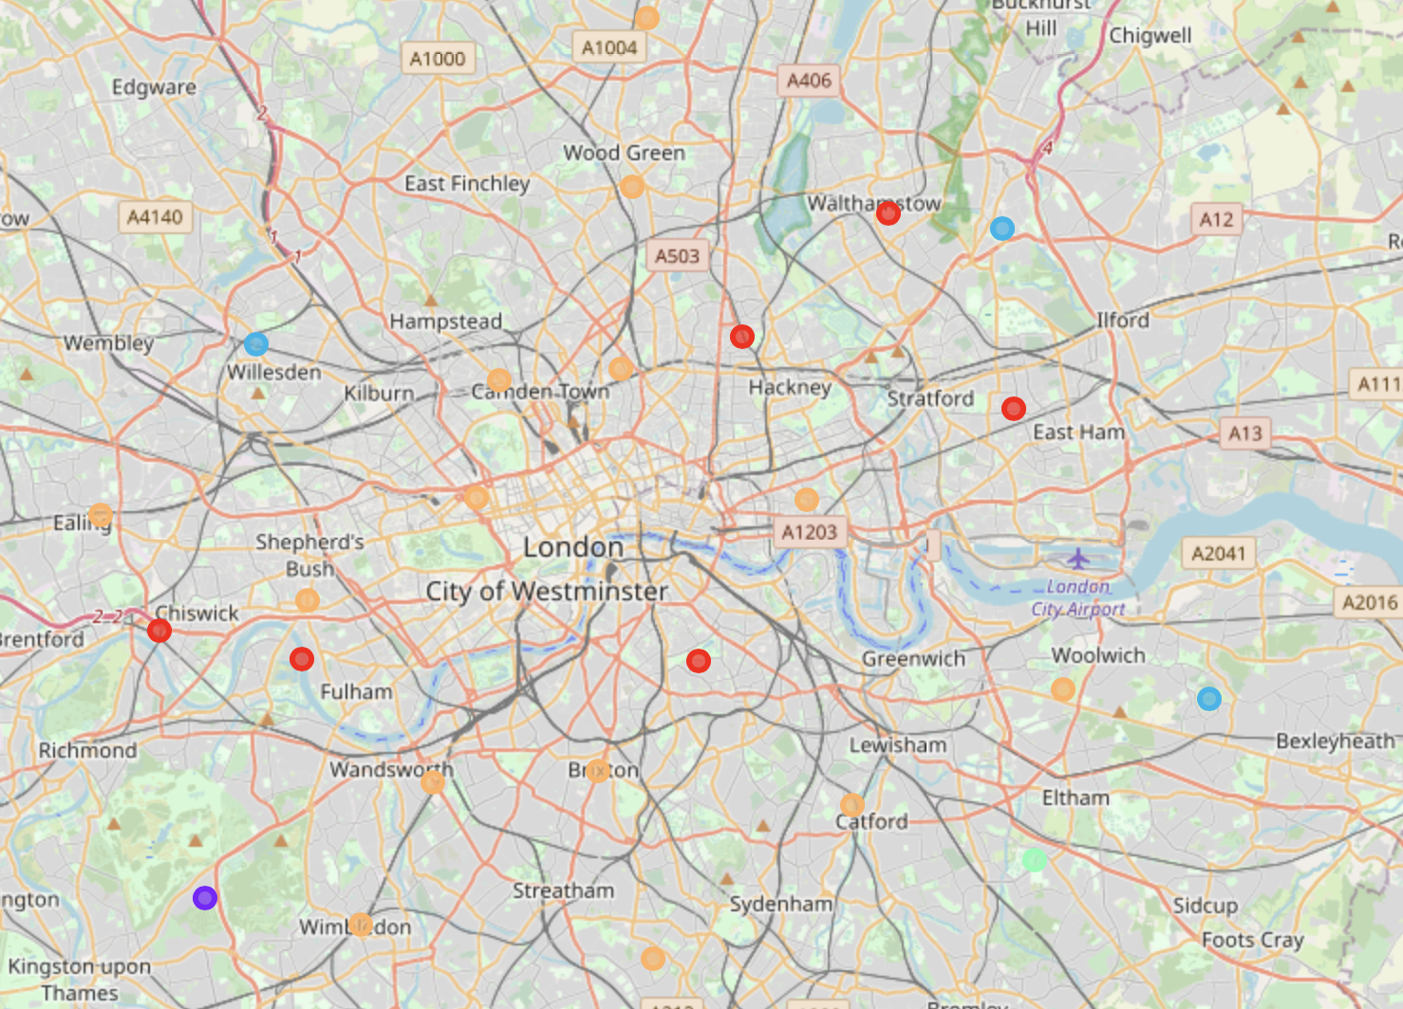

Figure 5: Center points of the schools of each borough with Folium Map

Respective average school ratings and venue category frequencies have been listed as follows;

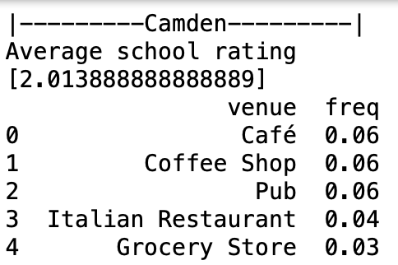 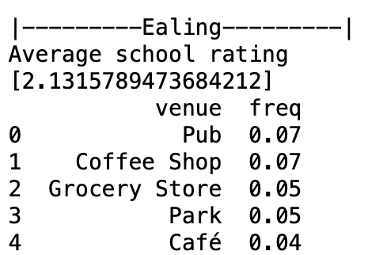

Figure 6: Example Screenshots of Borough informations according to the scool ratings and venue categories

After getting the venue data with Foursquare API, boroughs have been listed with the school ratings and venue categories. 438 of Venue category types were identified.

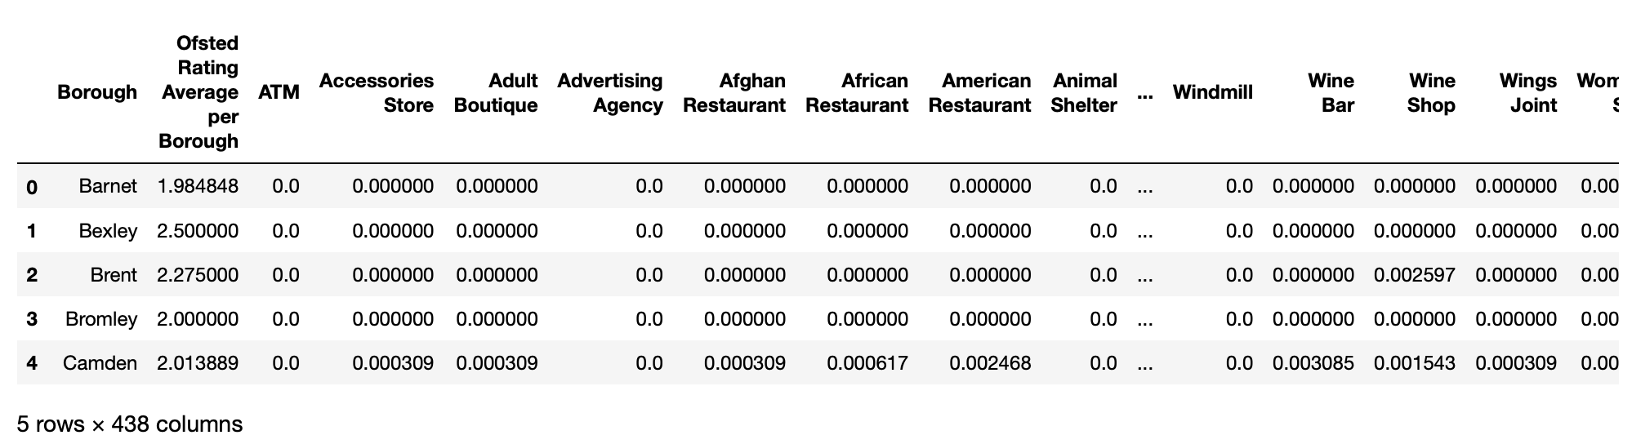

After listing the school averages and venue types, below table has been created to understand cluster types when kmeans algorithm is run.

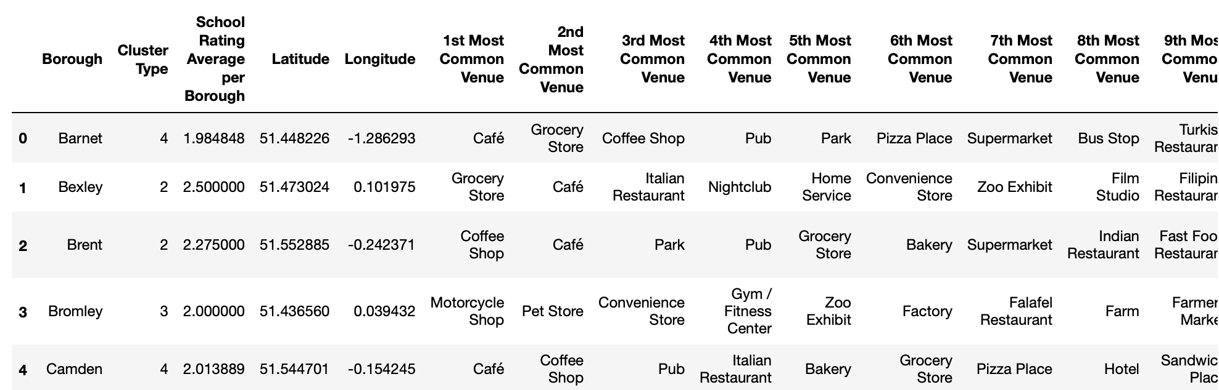

## Machine Learning Method

As the problem itself is basically targeting to cluster boroughs based on their respective attributes, KMeans algorithm was choosen for segmentation. K-Means algorithm is one of the most common cluster method of unsupervised learning.

Cluster quantity was decided to be 5, which may be evaluted and changed according to the city size, and customer expectation.

# Results

According to the kmeans clustering method, 27 unique boroughs have been clustered in 5 categories based on School Ratings and Venue Categories of each boroughs.

Number of clusters for the best analysis has been evaluated with elbow method.

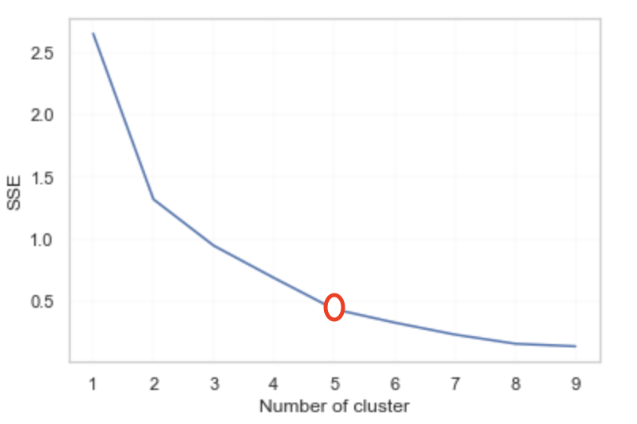

Based on the School Ratings and Venue Categories distrubition, the cluster types can be labeled as follow:

Type 0: Cafe Area with moderate rated schools

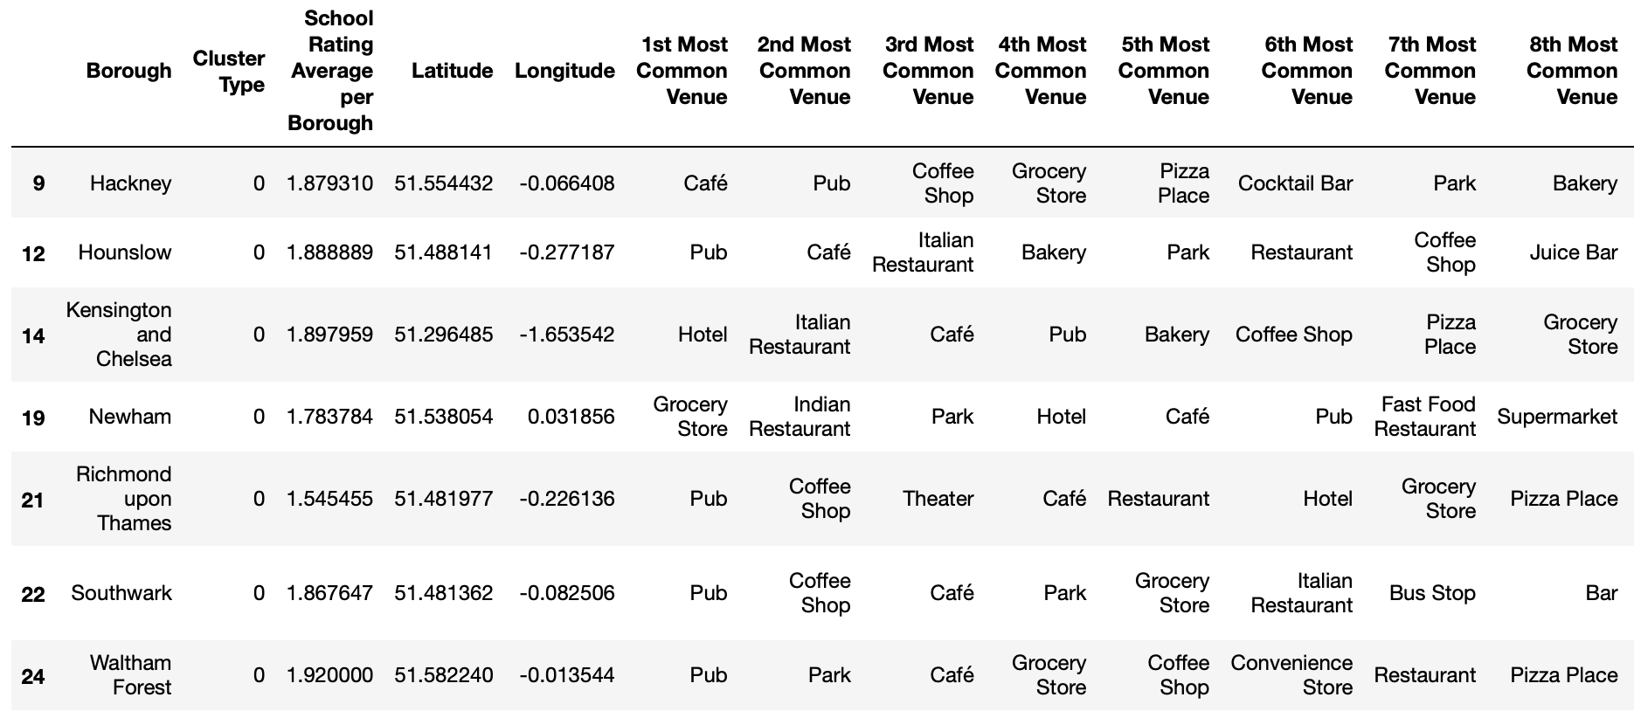

Type 1: Social Area with outstanding rated schools

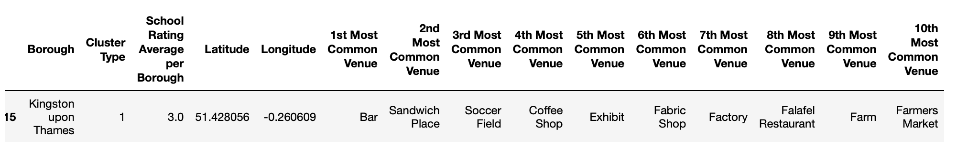

Type 2: Shopping Area with good rated schools

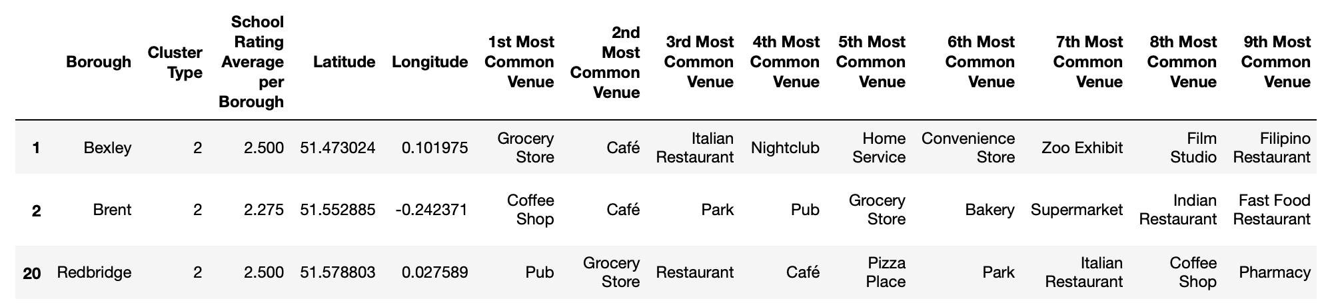

Type 3: Social Areas with good rated schools

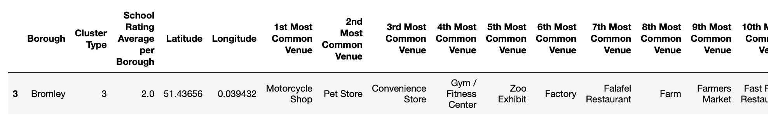

Type 4: Cafe Areas with good rated schools

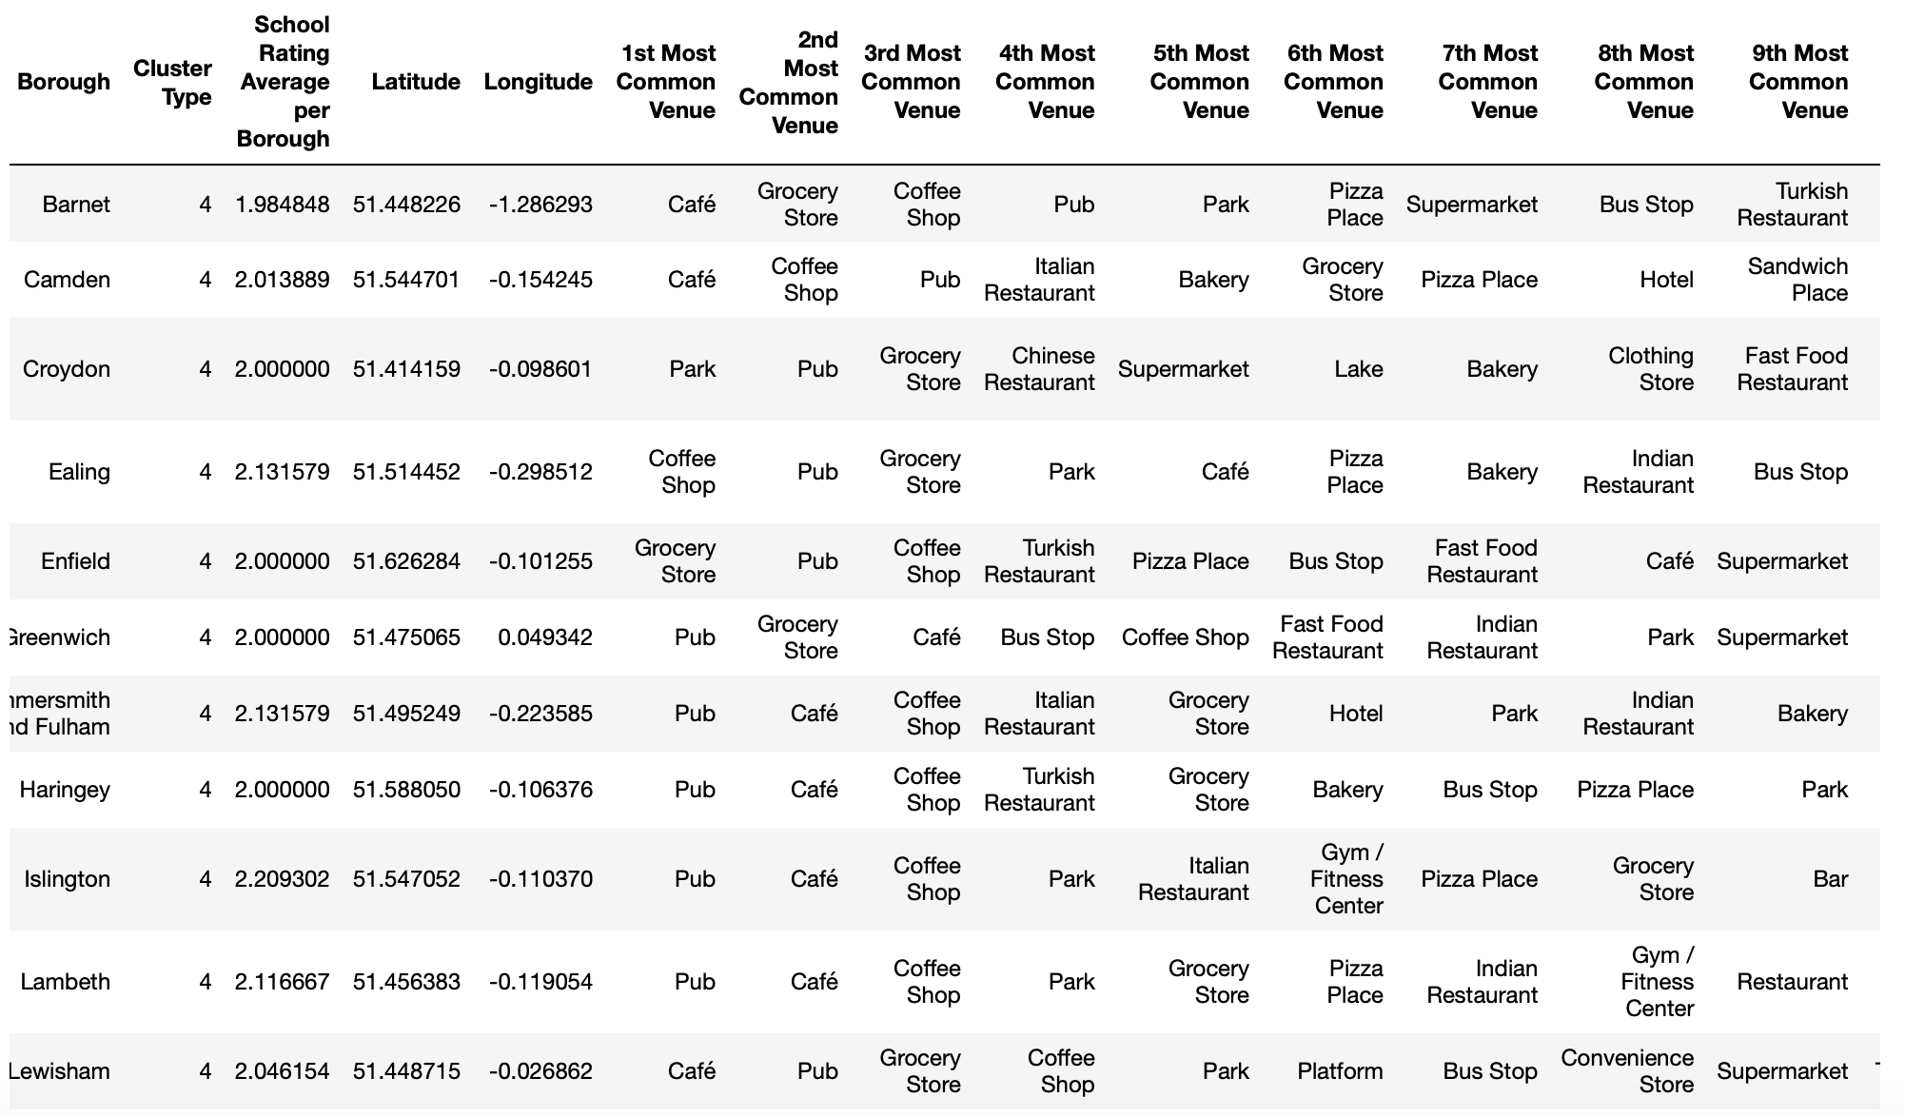

Boroughs with cluster labels and average schools labels can be seen on below folium map.

# Discussion

Based on the investigation above, for a family who wants their children get good education and the parents prefer to live in a social environment, Cluster type 1 or 4 would be good choices. Or Cluster type 2 would be also a good decision for the parents who like shopping.

As the similarities of the boroughs based on same attribute categories are evaluated, unsupervised machine learning method such as Kmeans is a good tool for clustering.

Moreover, the locations of the boroughs and labels are shown on folium map which can be helpful to give visual idea to new comers on London map.

# Conclusion

As discussed above as well, London is a charming city for the expats as well as their families. And the primary schools education is very important especially for the kids whose parents are relocating frequently due to various reasons.

Therefore, this kind of analysis would be very beneficial for the companies who brings expats to different locations or third part agencies.

Kind Regards,

Melek Hatipoglu